ARCHAEOLOGY ON SITE

Amateurs and professionals work with meticulous care to uncover the secrets of the past.

“There is no right way of digging, but there are many wrong ways.” So wrote Sir Mortimer Wheeler, one of the greatest 20th century archaeologists. When digging up the past, there is always the risk of destroying valuable evidence. Although diggers cannot help removing more recent layers of earth in order to get down to those underneath, it is important that they work methodically, keeping detailed records of everything they do so that all evidence is recorded before it is disturbed.

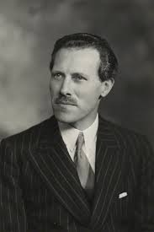
npg.org.uk

THE DIGGERS:

The leader of an archaeological dig must have a great deal of experience and scholarship. He needs much the same skills of leadership and organisation as an army officer, so it is not surprising that some of the world’s most successful archaeologists – Sir Mortimer Wheeler in the Indus Valley, Yigael Yadin of Israel, and General Pitt-Rivers in the 1890s – were all soldiers for part of their lives.

The director usually has a staff of about a dozen skilled people and a much larger number of actual workers. On anything but a small dig, the director has a skilled and experienced deputy. On a large dig, where more than one area may be excavated at the same time, there is a supervisor for each area. An experienced foreman handles the heavy digging, of which there is always a great deal.

Removing earth and finding objects is only part of the work on a dig. Specialists are needed to record everything that is found and its exact location. A draughtsman makes accurate on the spot drawings and plans. His work dovetails with that of the surveyor, who surveys and maps the site before and during the excavation.

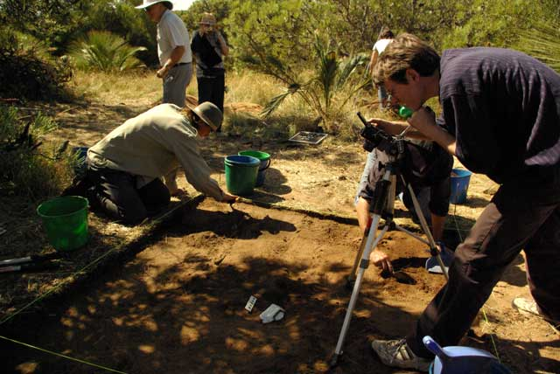
nd.edu.au

Many objects are in a very fragile or decayed condition when they are discovered, and a chemist must be on hand to preserve the finds until they can be given final treatment in a laboratory. Another specialist is the small finds recorder, who keeps meticulous records of all the finds, cleans them and labels them. He is backed up by an expert on pottery. Pottery is one of the greatest aids to dating archaeological finds and someone who can immediately identify pieces of pottery or shards can help the process of a dig enormously. Identifying coins is also a great help.

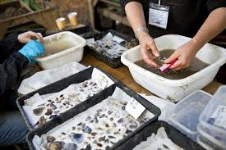
justinekibler.wordpress.com

Finally there are the labourers. Some may be hired: building workers have the right experience for much of the heavy earth shifting. Most large digs rely heavily on volunteers, principally students on vacation, to do the lighter and more detailed work, their interest and in some cases, knowledge, making up for a lack of experience.

THE SITE:

Many sites are chosen for excavation because surface features, written records, or local tradition indicate what lies buried. In open country aerial surveys are a great help. Often, old sites – particularly Roman ones – follow fairly predictable plans. A knowledge of what is likely to be there makes it easier to recognize what is actually found.

The director begins by marking off the site with his surveyor; then he selects the areas where the actual digging will take place. Sometimes it is necessary to explore a site by cutting a trial trench across it. But the best way of digging is to take a square of ground and go methodically down within the limits of the square. If the site is large enough, a series of squares can be dug out, forming a grid pattern with earth walls between. The walls allow the supervisor to see clearly what layers have been dug away.

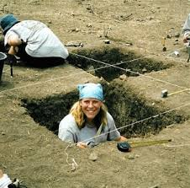
http://www.beadtree.net/our_roots.htm

Digging begins with spades and picks, but when undisturbed levels are reached more delicate, precise tools are needed. Small plastering trowels and old table knives make good tools for gently scraping away the soil around an object. Soft paint brushes are then used to remove the final traces of soil. Then the object can be sketched or photographed before it is removed. Workers have labelled trays and baskets beside them into which they put the finds for labelling and recording.

General Pitt-Rivers said that ‘a discovery dates only from the time of the record of it, and not the time of its being found in the soil’. Until other archaeologists can read about it, a dig has no scientific value. A really detailed record overcomes the great disadvantage of archaeology – the destruction of evidence. Future archaeologists may find apparently unimportant details of the greatest value in unravelling new problems.

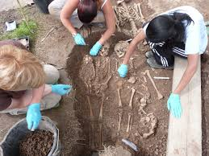
http://www.google.com.au/imgres

